NPTEL Online Course

# Wheeled mobile robots: Week 6 by Dr.Asokan Thondiyath

Assignment 6

1. Question 1:

“For a polygonal configuration space consists of edges joining all pairs of vertices that can see each other”.

The above statement is suitable for which path planning method?

* 1. Voronoi diagram method
  2. Cell decomposition methods
  3. Visibility graph method
  4. Approximate Cell Decomposition method

Solution: **Ans**(*c*)

Visibility graph method

1. Question 2:

Which of the following comes under graph search algorithm?

* 1. Depth first
  2. Cell decomposition
  3. Breadth first
  4. Visibility graph
  5. Voronoi diagram

Solution: **Ans**(*a and c*)

Breadth first

Depth first

1. Question 3:

The heuristic cost for all nodes in Dijikstra’s algorithm is equal to ______.

Solution: **0**

Heuristic cost = 0

1. Question 4:

Choose the True statements

* 1. The potential field method treats the robot as a point under the influence of an artificial potential field.
  2. The goal acts as a repulsive force and the obstacles act as an attractive force.
  3. The goal acts as an attractive force and the obstacles act as repulsive forces.
  4. The superposition of all forces is applied to the robot, which, in most cases, is assumed to be a point in the configuration space.

Solution: **Ans**(*a, c and d*)

The potential field method treats the robot as a point under the influence of an artificial potential field.

The goal acts as an attractive force and the obstacles act as repulsive forces.

The superposition of all forces is applied to the robot, which, in most cases, is assumed to be a point in the configuration space.

1. Question 5:

From the below list of algorithms, which of them does not use the deterministic graph search method

* 1. Multibug algorithm
  2. A* algorithm
  3. Bug Algorithm
  4. Dijkstra’s algorithm
  5. Grassfire Algorithm

Solution: **Ans**(a, *b, c and d*)

Multibug algorithm

Bug Algorithm

Dijkstra’s algorithm

Grassfire Algorithm

1. Question 6:

Choose the algorithm shown in below figure.

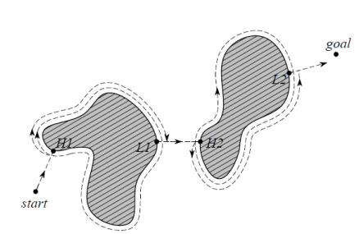

* 1. Grassfire Algorithm
  2. Bug1 Algorithm
  3. Breadth first search
  4. Depth first search
  5. Dijkstra’s algorithm
  6. A* algorithm
  7. Bug2 Algorithm
  8. Multibug algorithm

Solution: **Ans**(*b*)

Bug1 Algorithm

1. Question 7:

The below figure shows the start and the goal position for a robot to travel by avoiding the obstacle polygons. The shortest path the robot will follow from its start position to the goal position using visibility graph search method is.

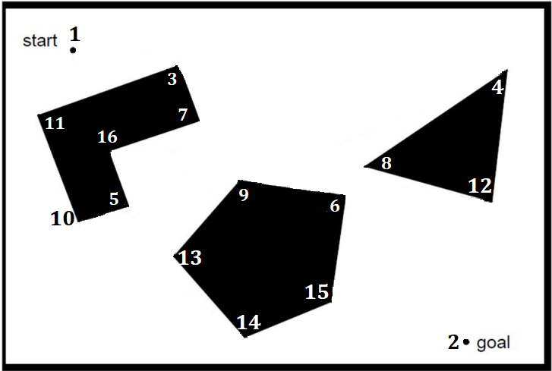

1. 1-5-9-6-2
2. 1-6-2
3. 1-3-6-2
4. 1-4-12-2

Solution: **Ans**(*c*)

1-3-6-2

1. Question 8:

Find the shortest path from ‘s’ to ‘t’ using the Dijkstra’s algorithm.

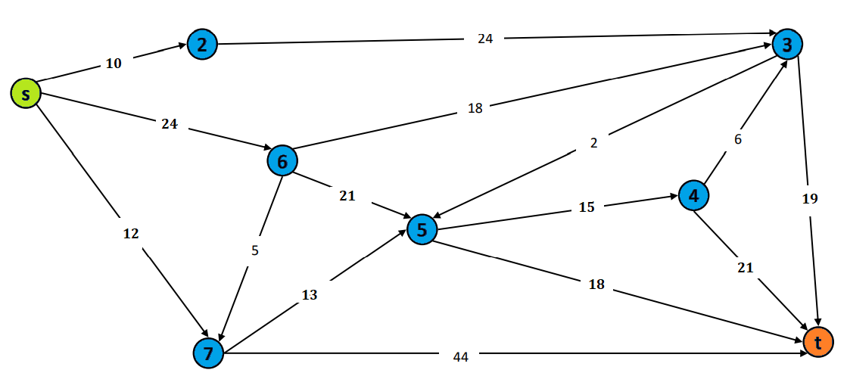

1. s⇒2⇒3⇒t
2. s⇒2⇒3⇒5⇒t
3. s⇒6⇒4⇒4⇒t
4. s⇒7⇒5⇒4⇒t
5. s⇒7⇒5⇒t

Solution: **Ans**(*e*)

s⇒7⇒5⇒t

1. Question 9:

Which graph search algorithm is used in Grassfire Algorithm?

* 1. Depth first
  2. Cell decomposition
  3. Breadth first
  4. Visibility graph
  5. Voronoi diagram
  6. Dijkstra’s algorithm

Solution: **Ans**(*c*)

Breadth first

1. Question 10:

“_____________ algorithm expands nodes starting from the start similar to breadth-first search, except that the neighbors of the expanded node are placed in the heap and reordered according to their value, which corresponds to the cost. Subsequently, the cheapest state on the heap (the top element after reordering) is extracted and expanded. This process continues until the goal node is expanded, or no more nodes remain on the heap. A solution can then be backtracked from the goal to the start”.

* 1. Depth first search
  2. Cell decomposition method
  3. A* algorithm
  4. Grassfire Algorithm
  5. Bug Algorithm
  6. Dijkstra’s algorithm

Solution: **Ans**(*f*)

Breadth first search